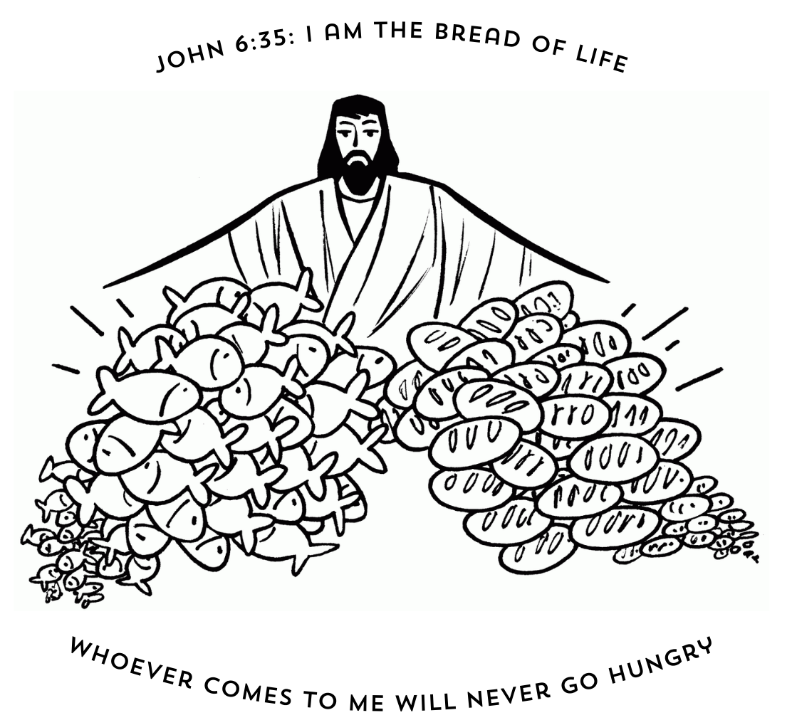

**10th Sunday after Pentecost**

**CHRIST LUTHERAN CHURCH** | Lodi, California

*July 28, 2024*

**WELCOME TO WORSHIP**

Welcome to Christ Lutheran Church. We pray that your soul will be strengthened by the good news about God’s grace, love, and forgiveness given to us. If you would like to learn more about our church, please speak with our pastor or one of our members after the service.

* **Bathrooms** are located in the fellowship hall. A changing table is located in the women’s bathroom.

**WORSHIP THEME**

The Lord graciously provides for his people. In their wandering in the wilderness, He gave them manna: bread from heaven to feed them on their long journey to the Promised Land. In Christ, he gives us the Bread of Life: the food that sustains us to eternal life and satisfies our every need. As we journey toward the Promised Land of our eternal home, we enjoy God’s many gifts to us not in self-serving indulgence, but in renewed righteousness and holiness.



***Setting II***

*We gather as a congregation to hear God’s Word proclaimed and respond with prayer, praise, and thanksgiving.*

**HYMN** *O Living Bread from Heaven* **| CW’93 314**

M: In the name of the Father, and of the Son, and of the Holy Spirit.

**C: Amen.**

**CONFESSION**

M: If we claim to be without sin, we deceive ourselves and the truth is not in us.

**C: If we confess our sins, God is faithful and just   
 and will forgive us our sins   
 and purify us from all unrighteousness.**

M: Let us confess our sins to the Lord.

**C: Holy God, gracious Father,   
 I am sinful by nature   
 and have sinned against you in my thoughts, words, and**

**actions.   
 I have not loved you with my whole heart;   
 I have not loved others as I should.   
 I deserve your punishment both now and forever.   
 But Jesus, my Savior, paid for my sins   
 with his innocent suffering and death.   
 Trusting in him, I pray: God, have mercy on me, a sinner.**

*Silence for meditation and reflection*

# absolution

M: Our gracious Father in heaven has been merciful to us. He sent his only Son, Jesus Christ, who gave his life as the atoning sacrifice for the sins of the whole world. Therefore, as a called servant of Christ and by his authority, I forgive you all your sins in the name of the Father and of the T Son and of the Holy Spirit.

**C: Amen.**

**Lord, Have Mercy**

M: In peace let us pray to the Lord.

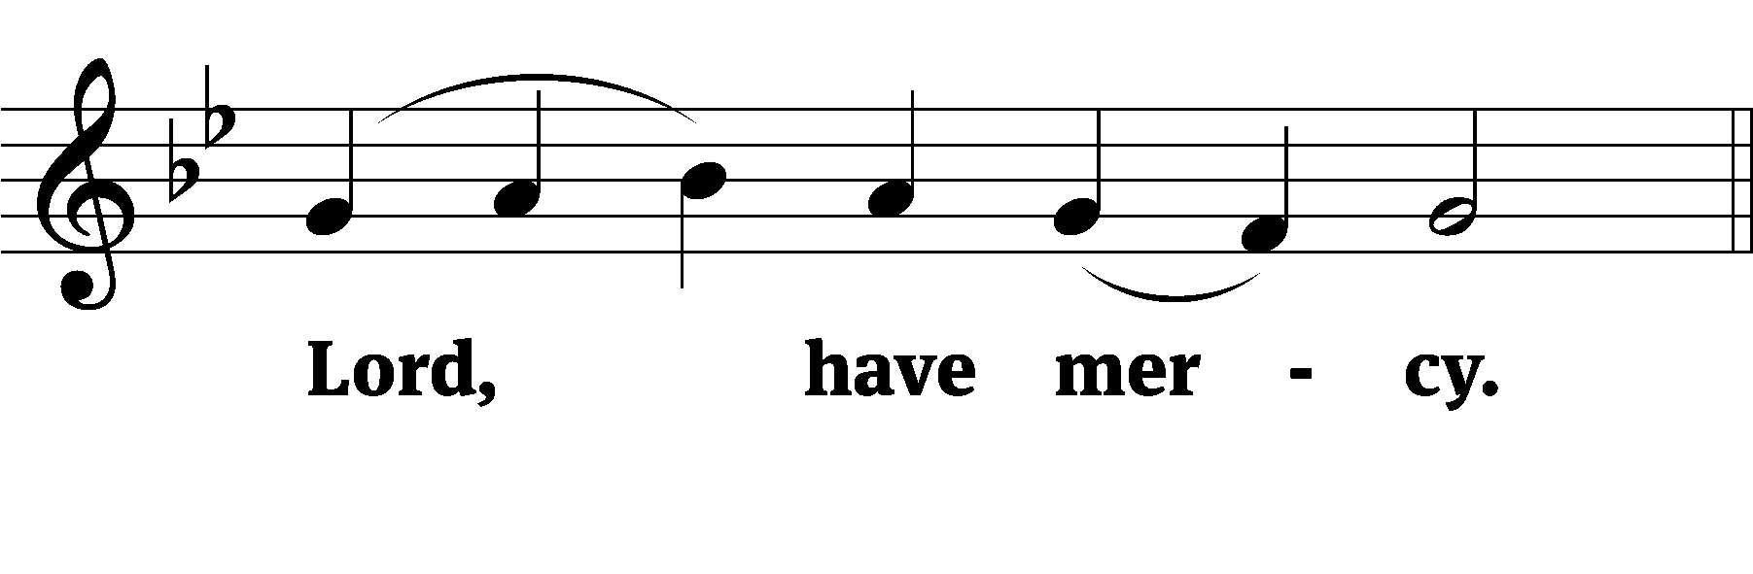

M: For the peace from above and for our salvation, let us pray to the Lord.

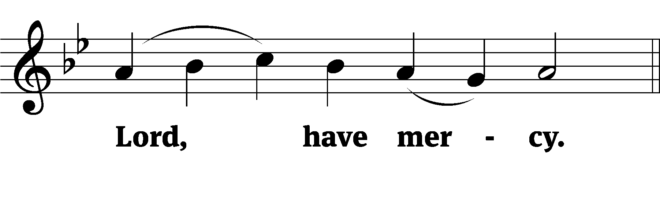

M: For the peace of the whole world, for the well-being of the Church of God, and for the unity of all, let us pray to the Lord.

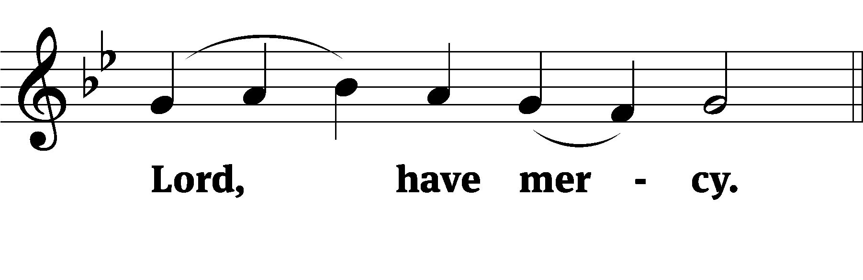

M: For this holy house and for all who offer here their worship and praise, let us pray to the Lord.

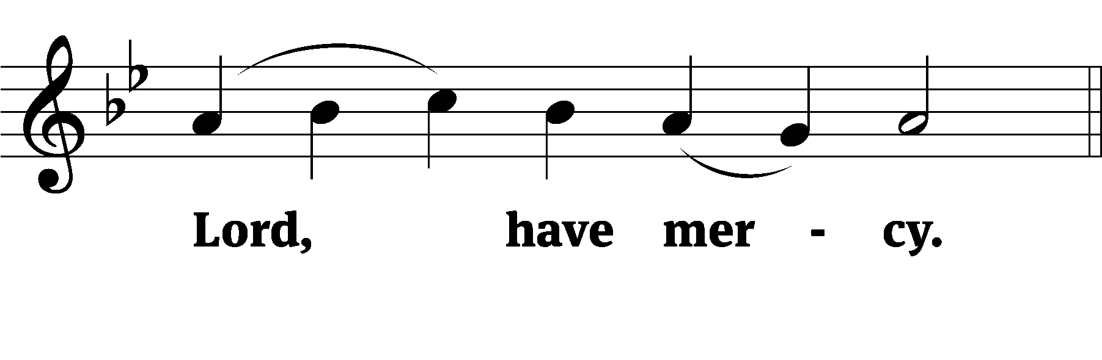

M: Help, save, comfort, and defend us, gracious Lord.

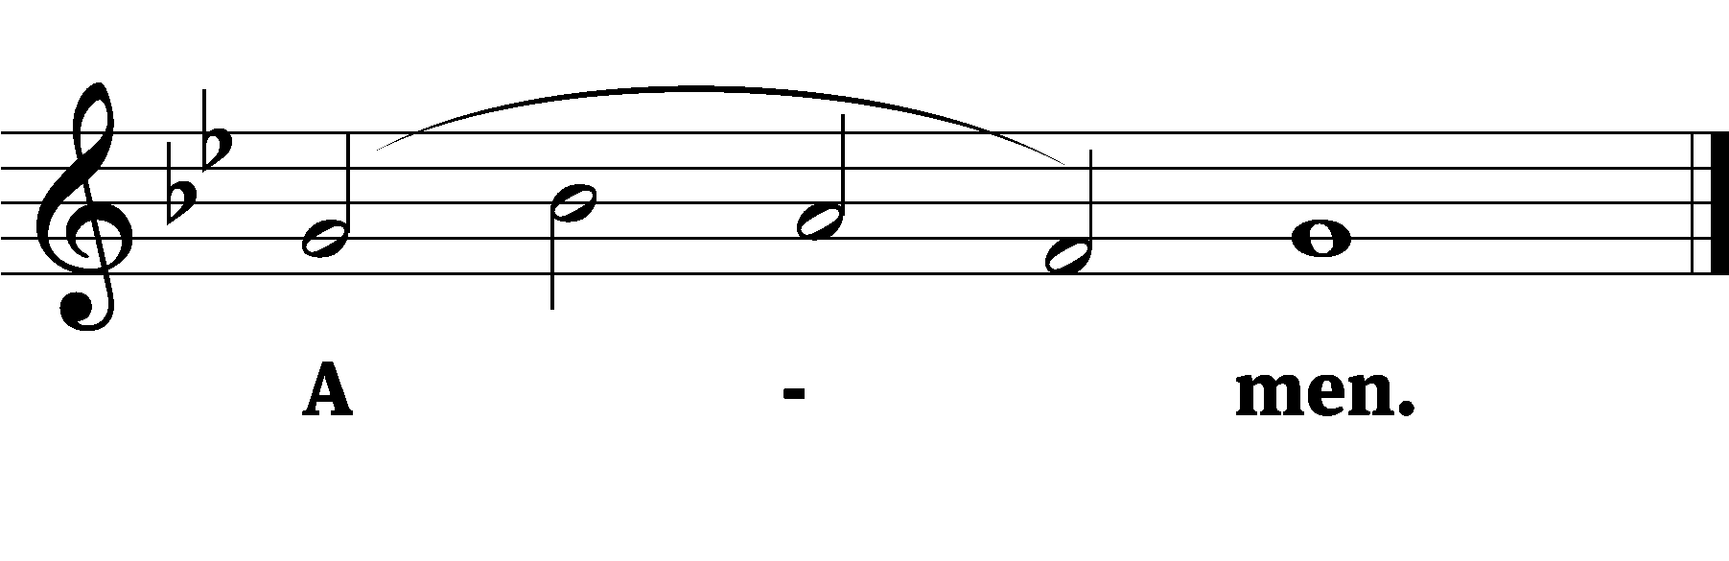

**Glory to God in the highest**



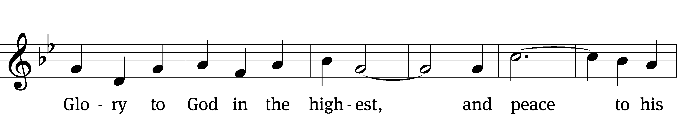

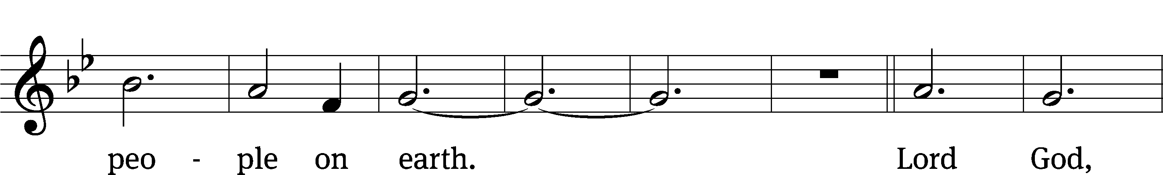

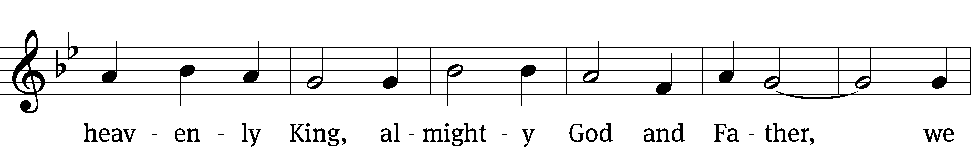

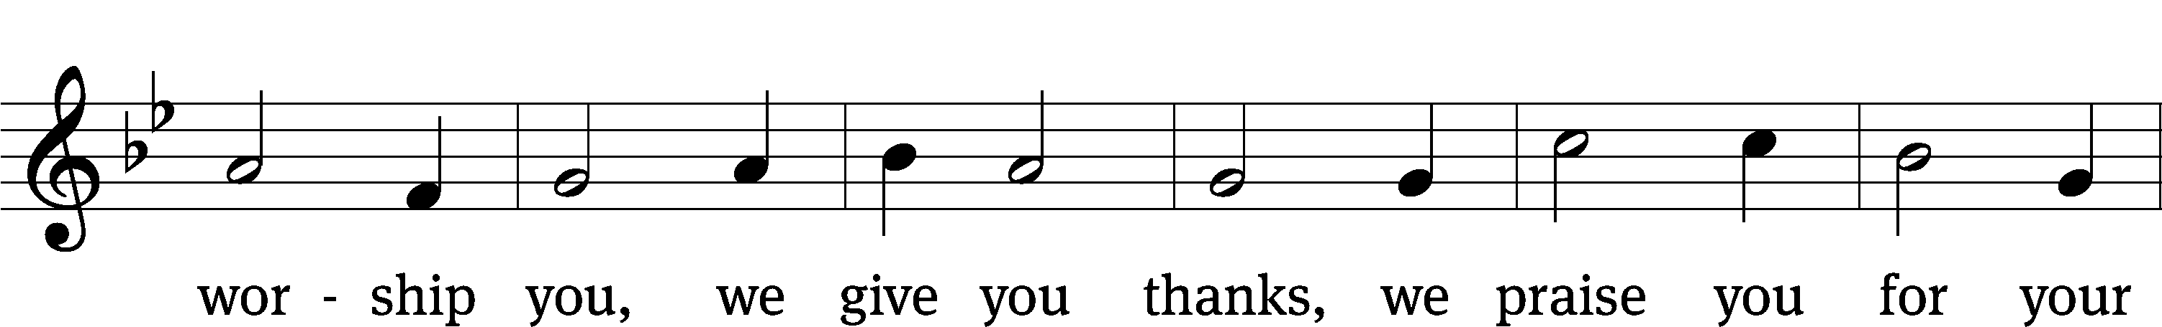

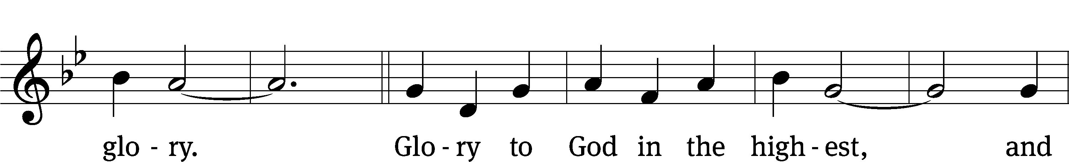



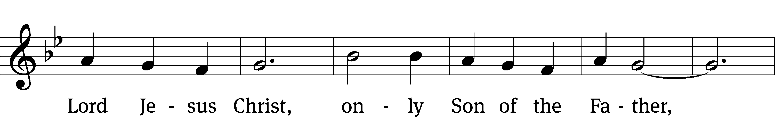

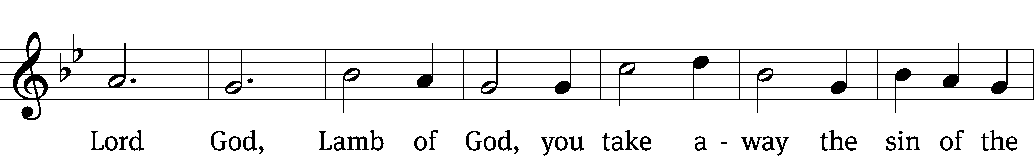

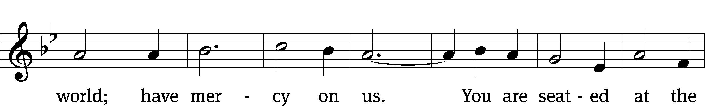

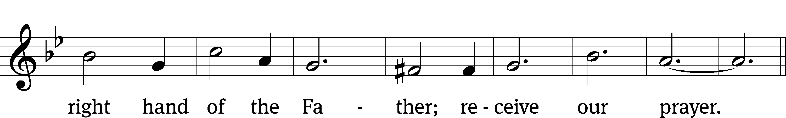

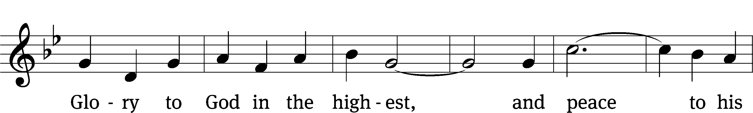

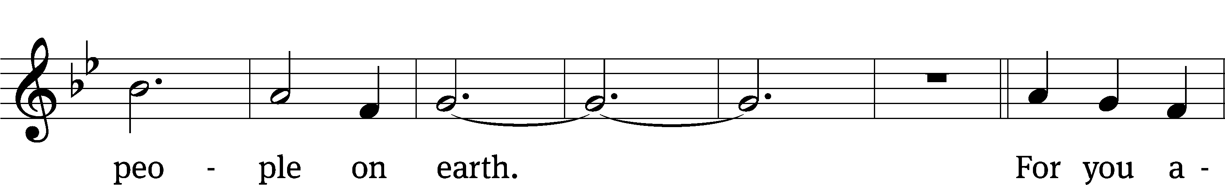

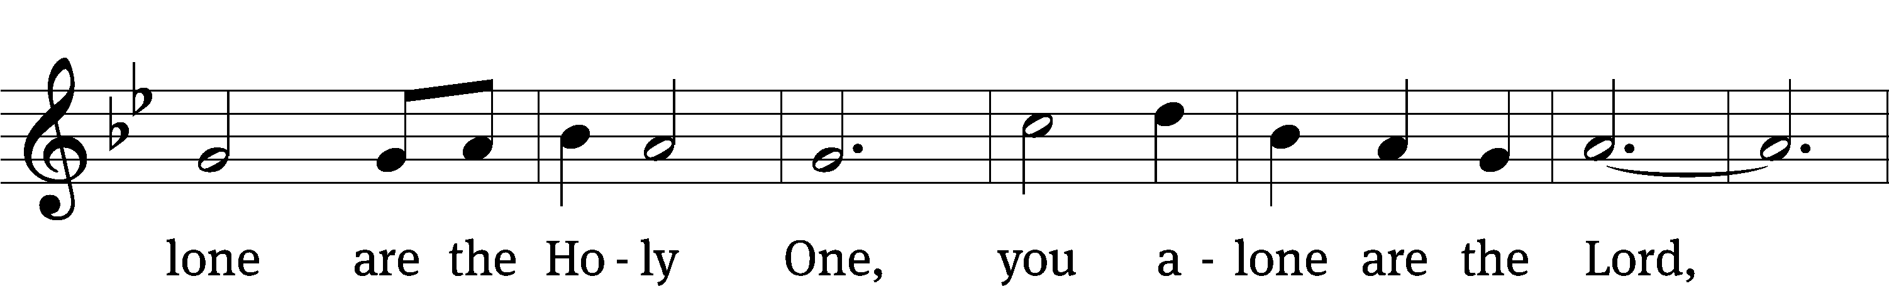

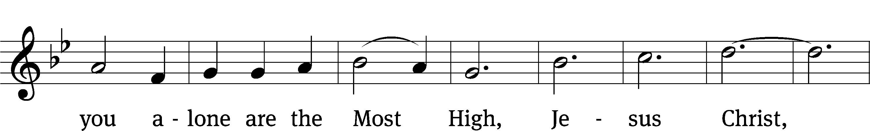

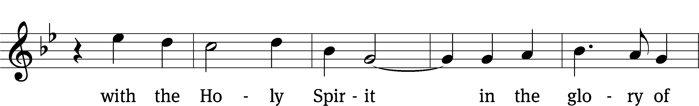

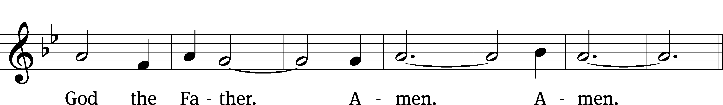

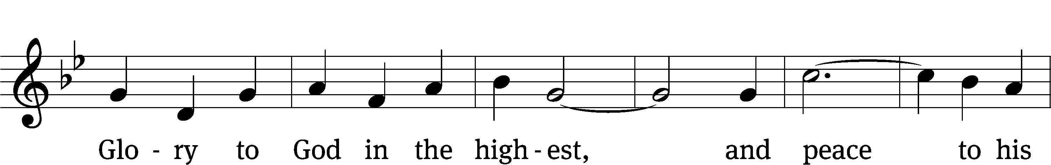



**PRAYER OF THE DAY**

M: Let us pray.

O God, you reveal your mighty power chiefly in showing mercy and kindness. Grant us the full measure of your grace that we may obtain your promises and become partakers of your heavenly glory; through Jesus Christ, your Son, our Lord, who lives and reigns with you and the Holy Spirit, one God, now and forever.

**C: Amen**

**FIRST LESSON** *Exodus 16:2–15*

*The Lord sends his people bread from heaven.*

**2**In the desert the whole community grumbled against Moses and Aaron. **3**The Israelites said to them, “If only we had died by the Lord’s hand in Egypt! There we sat around pots of meat and ate all the food we wanted, but you have brought us out into this desert to starve this entire assembly to death.”

**4**Then the Lord said to Moses, “I will rain down bread from heaven for you. The people are to go out each day and gather enough for that day. In this way I will test them and see whether they will follow my instructions. **5**On the sixth day they are to prepare what they bring in, and that is to be twice as much as they gather on the other days.”

**6**So Moses and Aaron said to all the Israelites, “In the evening you will know that it was the Lord who brought you out of Egypt, **7**and in the morning you will see the glory of the Lord, because he has heard your grumbling against him. Who are we, that you should grumble against us?” **8**Moses also said, “You will know that it was the Lord when he gives you meat to eat in the evening and all the bread you want in the morning, because he has heard your grumbling against him. Who are we? You are not grumbling against us, but against the Lord.”

**9**Then Moses told Aaron, “Say to the entire Israelite community, ‘Come before the Lord, for he has heard your grumbling.’”

**10**While Aaron was speaking to the whole Israelite community, they looked toward the desert, and there was the glory of the Lord appearing in the cloud.

**11**The Lord said to Moses, **12**“I have heard the grumbling of the Israelites. Tell them, ‘At twilight you will eat meat, and in the morning you will be filled with bread. Then you will know that I am the Lord your God.’”

**13**That evening quail came and covered the camp, and in the morning there was a layer of dew around the camp. **14**When the dew was gone, thin flakes like frost on the ground appeared on the desert floor. **15**When the Israelites saw it, they said to each other, “What is it?” For they did not know what it was.

Moses said to them, “It is the bread the Lord has given you to eat.

**PSALM** *Psalm 145, CW’93*

**SECOND LESSON** *Ephesians 4:17-24*

*The Lord makes us new.*

**17**So I tell you this, and insist on it in the Lord, that you must no longer live as the Gentiles do, in the futility of their thinking. **18**They are darkened in their understanding and separated from the life of God because of the ignorance that is in them due to the hardening of their hearts. **19**Having lost all sensitivity, they have given themselves over to sensuality so as to indulge in every kind of impurity, and they are full of greed.

**20**That, however, is not the way of life you learned **21**when you heard about Christ and were taught in him in accordance with the truth that is in Jesus. **22**You were taught, with regard to your former way of life, to put off your old self, which is being corrupted by its deceitful desires; **23**to be made new in the attitude of your minds; **24**and to put on the new self, created to be like God in true righteousness and holiness.

**VERSE OF THE DAY** *John 14:23*

**Alleluia. Jesus replied, “If anyone loves me, he will obey my teaching. My Father will love him, and we will come to him and make our home with him.” Alleluia.**

**THE GOSPEL** *John 6:24-35*

*We are made new in Jesus when he gives us the true Bread from Heaven.*

**24**Once the crowd realized that neither Jesus nor his disciples were there, they got into the boats and went to Capernaum in search of Jesus.

**25**When they found him on the other side of the lake, they asked him, “Rabbi, when did you get here?”

**26**Jesus answered, “Very truly I tell you, you are looking for me, not because you saw the signs I performed but because you ate the loaves and had your fill. **27**Do not work for food that spoils, but for food that endures to eternal life, which the Son of Man will give you. For on him God the Father has placed his seal of approval.”

**28**Then they asked him, “What must we do to do the works God requires?”

**29**Jesus answered, “The work of God is this: to believe in the one he has sent.”

**30**So they asked him, “What sign then will you give that we may see it and believe you? What will you do? **31**Our ancestors ate the manna in the wilderness; as it is written: ‘He gave them bread from heaven to eat.’”

**32**Jesus said to them, “Very truly I tell you, it is not Moses who has given you the bread from heaven, but it is my Father who gives you the true bread from heaven. **33**For the bread of God is the bread that comes down from heaven and gives life to the world.”

**34**“Sir,” they said, “always give us this bread.”

**35**Then Jesus declared, “I am the bread of life. Whoever comes to me will never go hungry, and whoever believes in me will never be thirsty.

M This is the Gospel of the Lord.

**C: Praise be to you, O Christ!**

**HYMN OF THE DAY** *My Faith Looks Up To Thee***| CW’21 811**

**SERMON** *Genesis 3*

**APOSTLES’ CREED**

**I believe in God, the Father Almighty,**

**maker of heaven and earth.**

**I believe in Jesus Christ, his only Son, our Lord,**

**who was conceived by the Holy Spirit,**

**born of the Virgin Mary,**

**suffered under Pontius Pilate,**

**was crucified, died, and was buried.**

**He descended into hell.**

**The third day he rose again from the dead.**

**He ascended into heaven**

**and is seated at the right hand of God the Father Almighty.**

**From there he will come to judge the living and the dead.**

**I believe in the Holy Spirit,**

**the holy Christian Church,**

**the communion of saints,**

**the forgiveness of sins,**

**the resurrection of the body,**

**and the life everlasting. Amen.**

**OFFERING**

*In response to God’s love and forgiveness, we give back a portion of what he has given us. The members of Christ Lutheran Church have joined to proclaim the gospel to this community. These offerings support that work. While our guests are welcome to participate, they should not feel obligated to do so.*

**PRAYER OF THE CHURCH**

M: Gracious heavenly Father, as You provided for the Israelites during their journey through the wilderness to the land You had promised, give us confidence to trust in You.

**C: We look to Your hand to provide all we need for this life and for the life to come.**

M: Holy One, Your Son gives us the Office of the Ministry, that Your people might be equipped to serve and be built up into His one Body. Remember in Your compassion all who speak Your Word. Give them faithfulness and honesty in their teaching, that Your children would be freed from all deceit to speak Your truth to one another in love.

**C: May we gladly learn from your servants and grow in every way into Christ.**

M: O Lord, grant us true unity in the faith. Preserve us in pure doctrine; grant harmony in our congregation, district and Synod; and bestow on us charitable hearts that put the best construction on what we see and hear.

**C: Make us slow to speak and quick to listen.**

M: God and Father of all, enable us to walk in humility, gentleness and patience, that we would bear with one another in love and be eager to maintain the unity of the Spirit in the bond of peace.

**C: Fill us with the fruit of your Spirit.**

M: Mighty One, You establish civil government to be a blessing. To Your mercy, then, we commend our president, our Congress, our justices and magistrates, and all who serve the public in any way. Keep them honest, fill them with wisdom and uphold them in every good deed. During this election year, grant a spirit of peace and cooperation to all our citizens.

**C: Graciously grant us quiet lives in which we can share your gospel.**

M: Show Your mercy to the sick and hospitalized [including _____________]. Provide doctors, nurses and other medical professionals to care for those who need health and healing. Hear us as each of us prays for a family member, friend, or acquaintance in need.

*Silent Prayer*

M: Lord, we come as a people tossed to and fro by the manifold changes of this mortal life. Help us to know, in You, that which is eternal. Give us confidence in the suffering and death of Christ, that we may rejoice that You are with us always and await His joyous appearing with all the saints; through the same Jesus Christ, our Lord, who lives and reigns with You and the Holy Spirit, one God, now and forever.

**C: Amen.**

**LORD’S PRAYER**

**C: Our Father, who art in heaven, hallowed be thy name,**

**thy kingdom come, thy will be done**

**on earth as it is in heaven.**

**Give us this day our daily bread; and forgive us our trespasses,**

**as we forgive those who trespass against us;**

**and lead us not into temptation, but deliver us from evil.**

**For thine is the kingdom and the power**

**and the glory forever and ever. Amen.**

M: O Lord God, our heavenly Father, pour out the Holy Spirit on your faithful people. Keep us strong in your grace and truth, protect and comfort us in all temptation, and bestow on us your saving peace, through Jesus Christ, our Lord.

**C: Amen.**

**THE BLESSING**

M**:** The Lord bless you and keep you.

The Lord make his face shine on you and be gracious to you.

The Lord look on you with favor and ✙ give you peace.

**C: Amen.**

**CLOSING HYMN** *Day By Day***| CW’21 803**

**COPYRIGHT INFORMATION**

*Content requiring a copyright license is reproduced under OneLicense.net #A-718312. All rights reserved. The Common Service: Texts revised from The Lutheran Hymnal, 1941. Music revised by James Engel. Scripture Quotations: From the Holy Bible, New International Version (NIV 1984), © 1973, 1978, 1984 by Biblica, Inc.*



**13009 N. Elderberry Ct.**

**Lodi, CA 95242**

[www.christlodi.org](http://www.christlodi.org)

209-368-6250

Pastor Tim Leistekow

**WELCOME TO CHRIST EV. LUTHERAN CHURCH!**

We preach a message of forgiveness, hope and peace

through the death and resurrection of Jesus Christ.

Families and individuals of all ages will find opportunities

both to grow and to serve.

Our mission statement:

**Look what Christ is doing!**

He binds us together in fellowship

He gathers us in for worship

He builds us up for service

He sends us out with the gospel

*“Now you are the body of Christ,*

*and each one of you is a part of it.”*

*(1 Corinthians 12:27)*